



Business Requirement Document
Supply Chain Management
NWS Technical Evaluation Approval
DOCUMENT FOR

Table of Contents:
Table of Contents: 1
1. Introduction 2
1.1 Business Need 2
1.2 Expected Business Outcomes 2
1.3 Project Scope Summary 2
2. Business Requirement Details 3
2.1 Requirement Description 3
Header Fields 3
2.2 Functional Tabs 4
2.3 Workflow & Approval Process 4
3. System Integration 5
4. Non-Functional Requirements 5
5. Process Flow 6
6. Assumptions & Constraints 6
7. Risks & Mitigation 6
8. Report 7
9. Application Prototype 7
11. Acceptance Form 8
12. Open and Close Issues 8
12.1 Open Issues 8
12.2 Closed Issues 8

1. Introduction

1.1 Business Need
Currently, the Technical Evaluation Approval process is EBS handled through Apex E-Forms and templates and meeting minutes.
To streamline this process and ensure system-driven governance, a custom Technical Evaluation Approval application will
be developed using Oracle Visual Builder Cloud Service (VBCS), integrated with Oracle Fusion Sourcing. This will allow
Contract Holders to initiate, review, and track technical approvals directly from the Oracle Fusion Negotiation page.

1.2 Expected Business Outcomes
- Automated technical approval workflow within Oracle Fusion.
- Enhanced transparency and accountability for tender approvals.
- Digital records with audit trail for all actions.
- Seamless data integration with Fusion Negotiation DFFs.
- Standardized PDF generation for approval documentation.

1.3 Project Scope Summary
The scope includes developing a custom VBCS application integrated with Oracle Fusion. The application will:
- Enable Contract Holders to initiate approvals via a “Technical Evaluation Approval” button.
- Fetch negotiation details automatically from Oracle Fusion.
- Support multi-level approval workflow via PCS (Process Cloud Service).
- Generate approval summary PDF reports using BI Publisher.

2. Business Requirement Details

2.1 Requirement Description
After completion of technical scoring, the Contract Holder clicks the “Technical Evaluation Approval” button available
on the Oracle Fusion Negotiation page (enabled when status = ‘Evaluation Completed: Technical’). The custom VBCS page
opens with pre-populated tender data, allowing entry of Objective, Background, SCM Comments, Division Recommendation,
and Committee Decision fields. Once submitted, the approval request is routed to the committee via PCS workflow.
The approval outcome is reflected in both the custom page and Fusion Negotiation DFF fields.

Header Fields
Field Name | Description | Behavior
Tender Number | Unique tender reference number from Fusion Negotiation | Pre-populated
Tender Title | Title of the tender | Pre-populated
Tender Publish Date | Date when the tender was published | Pre-populated
Tender Close Date | Closing date of tender submission | Pre-populated
Technical Unlock Date | Date when technical bids were unlocked | Pre-populated
Technical Scoring Completion Date | Date of technical scoring completion | Pre-populated
Tender Owner | Person responsible for the tender | Pre-populated
Objective | Purpose of the evaluation request | User Input (1000 chars)
Background | Detailed explanation | User Input (Unlimited)
SCM Comment | Comment from SCM | User Input (1000 chars)
Division’s Recommendation | Division’s remarks or recommendation | User Input (1000 chars)
Committee Decision | Final committee decision | User Input (1000 chars)
Attachments | Upload related documents | User Input
Approval Status | Displays current workflow status | System Generated

2.2 Functional Tabs
• Header Details – Displays pre-populated and user-entered information.
• SCM/Division Comments – Section for entering SCM and division-specific remarks.
• Committee Decision – Tab for entering committee conclusions.
• Attachments – Upload and view supporting documents.
• Approval History – View approval workflow trail.

2.3 Workflow & Approval Process
Once submitted, the Technical Evaluation Approval record follows a workflow managed in PCS. Available actions are
Approve, Reject, and Withdraw. Approval decisions are synchronized with Fusion Negotiation DFF fields, and status is
visible on the custom VBCS page and Fusion header.

3. System Integration

System | Module | Integration Point | Description
Oracle Fusion | Sourcing | Negotiation Page | Fetch and update negotiation header and DFF fields
VBCS | Custom Page | Technical Evaluation Page | Interface for user entry and submission
PCS | Workflow | Approval Routing | Approval routing and tracking
BI Publisher | Reports | PDF Output | Generate Technical Evaluation PDF document

4. Non-Functional Requirements
- Security: Role-based access (Contract Holders, SCM, Committee Members)
- Performance: Response < 3 seconds
- Scalability: Concurrent multi-user access supported
- Audit: Log user actions, timestamps
- Availability: 99.5% uptime

5. Process Flow
1. Contract Holder completes technical scoring.
2. “Technical Evaluation Approval” button enabled.
3. User opens custom page, enters details.
4. Form submitted for approval via PCS.
5. Committee members approve/reject/withdraw.
6. Status updated in Fusion Negotiation DFF.
7. PDF generated as approval report.

6. Assumptions & Constraints
- Tender must be in status “Evaluation Completed: Technical” before initiation.
- Approvers are predefined in PCS configuration.
- Integration depends on Fusion REST API uptime.

7. Risks & Mitigation

Risk | Impact | Mitigation
API downtime | Delay in fetching data | Implement retry and alert logic
Workflow delay | Approval process blocked | Enable escalations and reminders
PDF generation error | Missing reports | Maintain backup BI template

8. Report
The system generates a Technical Evaluation Approval PDF showing header, comments, and decisions.

9. Application Prototype
Prototype includes header, comments, decision, and workflow history tabs.
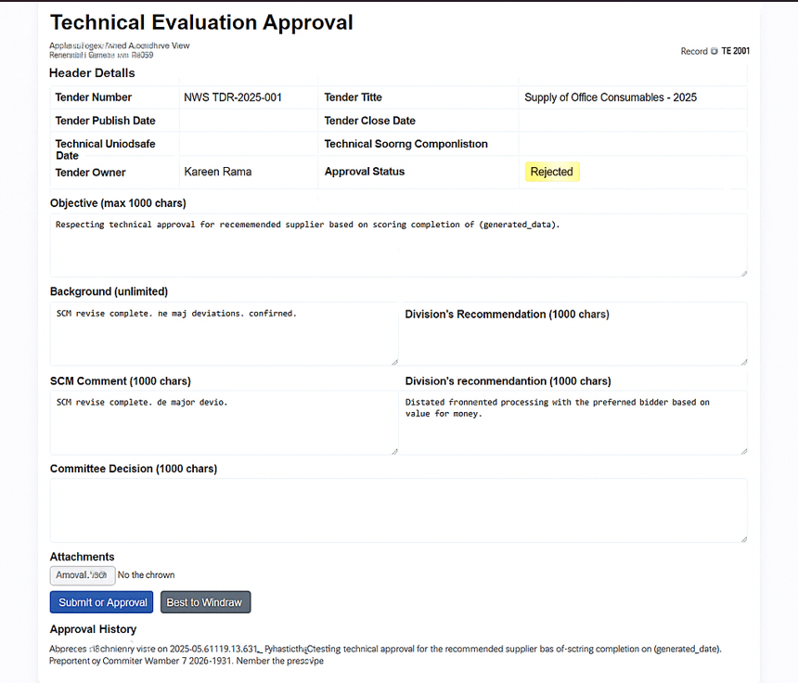

11. Acceptance Form
Project Name: | NWS Oracle Fusion Implementation
Document Name | NWS Technical Evaluation Approval
Company Name: | 4i Apps Solutions
Name of Management: | Nama Water Services
Approved By (System Owner):
Designation:

12. Open and Close Issues

12.1 Open Issues
S. No | Issue | Resolution | Responsibility | Target Date | Impact Date
1 | Approval matrix finalization pending | To be confirmed with SCM team | NWS SCM Team
2

12.2 Closed Issues
S. No | Issue | Resolution | Responsibility | Target Date | Impact Date
1
2

